 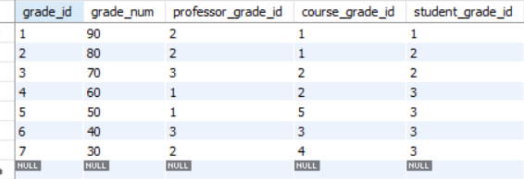





use practice1;

SELECT *

FROM grades g [-left side]

INNER JOIN professors p [-right side]

ON p.professor_id = g.professor_grade_id;

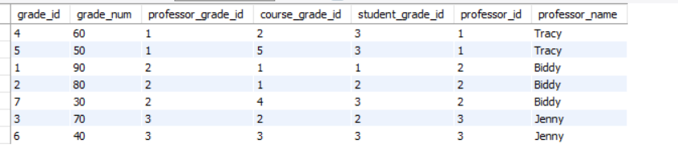

AVG GRADE FOR EACH PROFESSOR

use practice1;

SELECT p.professor_name, avg(g.grade_num)

FROM professors p

JOIN grades g

ON p.professor_id = g.professor_grade_id

GROUP BY p.professor_name;

Top grades for each student

use practice1;

SELECT s.student_name,c.course_name,max(g.grade_num)

FROM students s

join grades g

on s.student_id = g.student_grade_id

join courses c

on c.course_id = g.course_grade_id

group by s.student_name;

Group student by courses they enrolled in???

use practice1;

SELECT s.student_name,c.course_name

FROM students s

join grades g

on s.student_id = g.student_grade_id

join courses c

on c.course_id = g.course_grade_id

order by s.student_name;

Average grade for each course sorted descending

use practice1;

SELECT avg(g.grade_num) as Average_Grade,c.course_name

FROM grades g

join courses c

on c.course_id = g.course_grade_id

group by c.course_name

order by g.grade_num desc;

Finding which student and professor have the most courses in common?

select student_name,max(common) as common

from

(

SELECT s.student_name,g.professor_grade_id,count(*) as common

FROM students s

join grades g

on s.student_id = g.student_grade_id

join courses c

on c.course_id = g.course_grade_id

group by g.professor_grade_id, s.student_name

) as hello;

returns

|  |  |
| --- | --- |
| Student_name | Common |
| Kyle | 2 |

use practice1;

SELECT s.student_name,g.professor_grade_id,count(*) as common

FROM students s

join grades g

on s.student_id = g.student_grade_id

join courses c

on c.course_id = g.course_grade_id

group by g.professor_grade_id, s.student_name;

returns

name|prof id| common

|  |  |  |
| --- | --- | --- |
| Kyle | 1 | 2 |
| Fei | 2 | 1 |
| Kristine | 2 | 1 |
| Kyle | 2 | 1 |
| Fei | 3 | 1 |
| Kyle | 3 | 1 |

select professors.professor_name,b.student_name,max(common) as similiarity

from professors

join(

SELECT s.student_name,g.professor_grade_id,count(*) as common

FROM students s

join grades g

on s.student_id = g.student_grade_id

join courses c

on c.course_id = g.course_grade_id

group by g.professor_grade_id, s.student_name

) as b

on professors.professor_id = b.professor_grade_id;

|  |  |  |
| --- | --- | --- |
| Professor_name | Student_name | similiarity |
| Tracy | Kyle | 2 |